Grammar  Using fronted adverbials for when and where. Practice starting sentences with these fronted adverbials then marking the clause with a comma. You can write about anything you want to or focus on an area of the curriculum.  Example:  In the hazy distance, a strange figure dressed in colouful attire strode with confidence down the dusty path.  As the clock struck 12 o’clock, the despairing townspeople of Hamelin hung their tired heads at the thought of no end to this nightmare. |  | Religious Education  Our RE topic this half term is ‘Christmas – Exploring the symbolism of Light’.  We are looking at Christmas and Hanukkah the Jewish festival of light.  Research about Diwali, the Hindu Festival of light and create an information page about this.  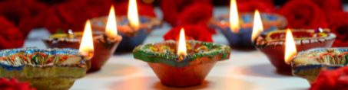 | English  Our English unit this half term is Fairy Tales – Ramaysa. Create a new character for a fairy tale with the same strange personality and dress. Write a description of this character including their: appearance, personality, special powers and the setting in which this character would appear in your story.  
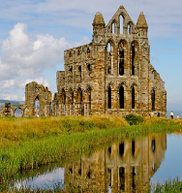  History  This half term we are learning about the Anglo-Saxons. Find out about religion in Britain during this Medieval time. |  | Year 4 Homework Grid  Autumn 2 | Multiplication Tables  Remember to practice your timetables – use Purple Mash if you have access to a computer, laptop or tablet. I have set this as a 2Do with a focus on 3x, 4x and 6 times tables this half term.
Reading  This half term the focus is inference. When you read a book – infer the characters thought, feelings and actions as a spider diagram. | Maths  Addition and Subtraction of 4 digit numbers has been our focus. Practice creating your own examples and solving them. | Design Technology  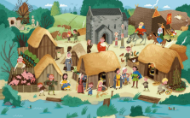  Using any materials you can find at home, make an Anglo-Saxon settlement typically found in Britain during this time. | PSHE  Our topic this half term is all about how we treat each other with respect.  Draw a picture to show what you think respect would look like. Explain what is happening in your picture.

